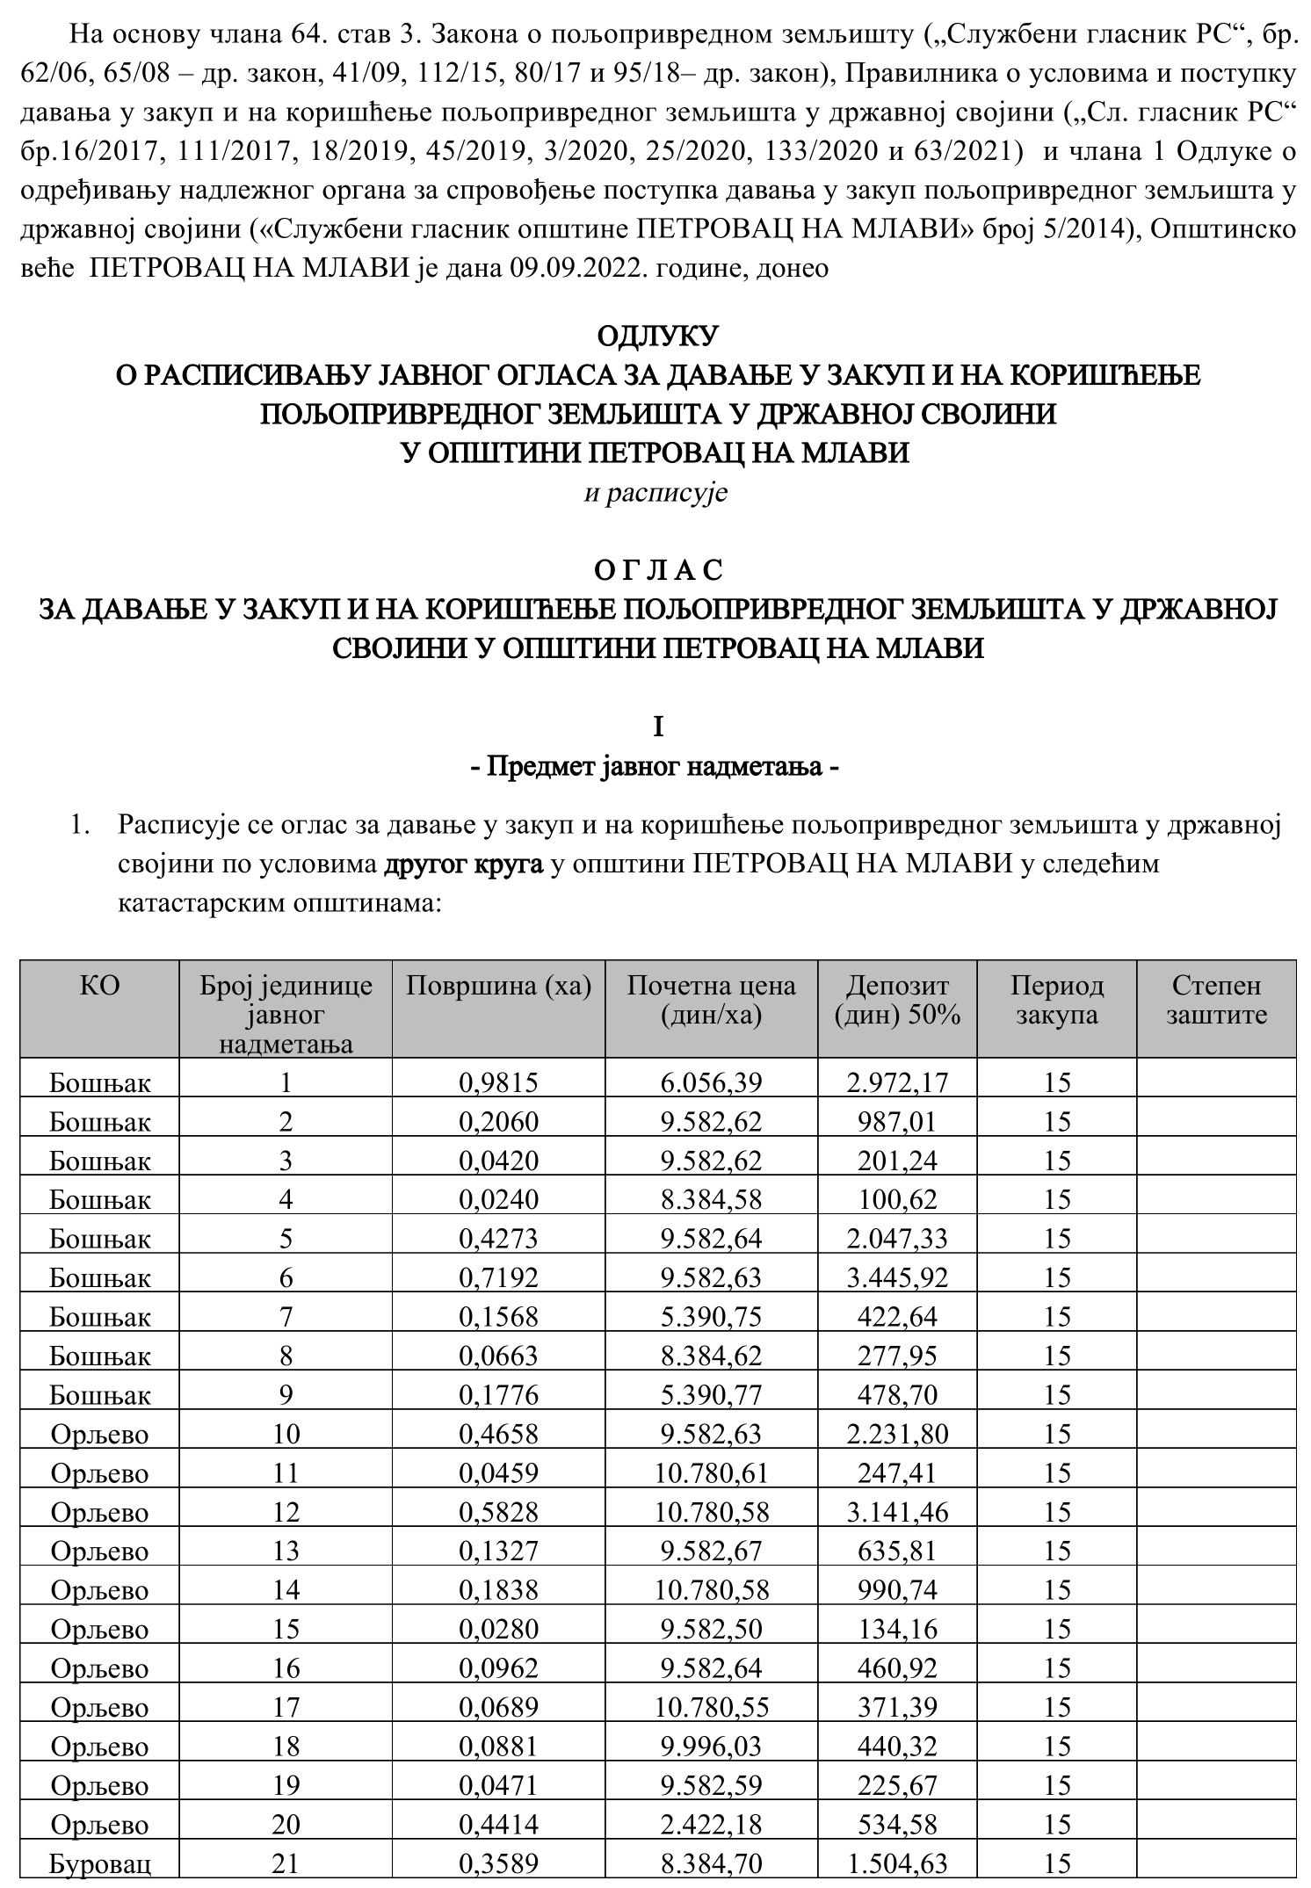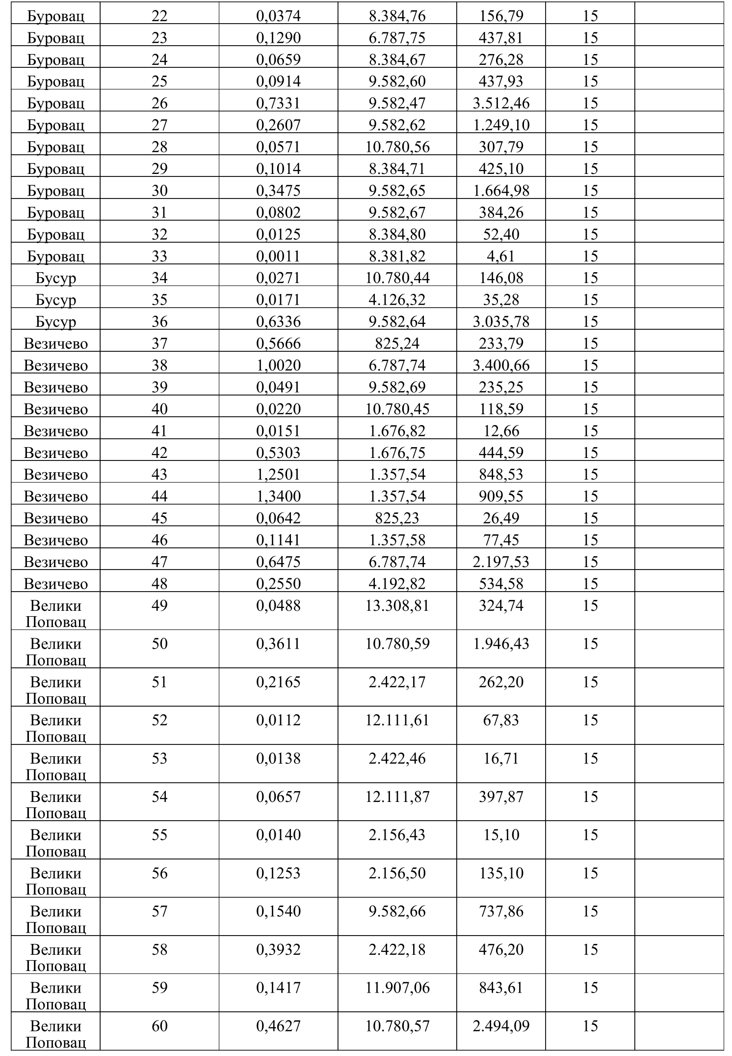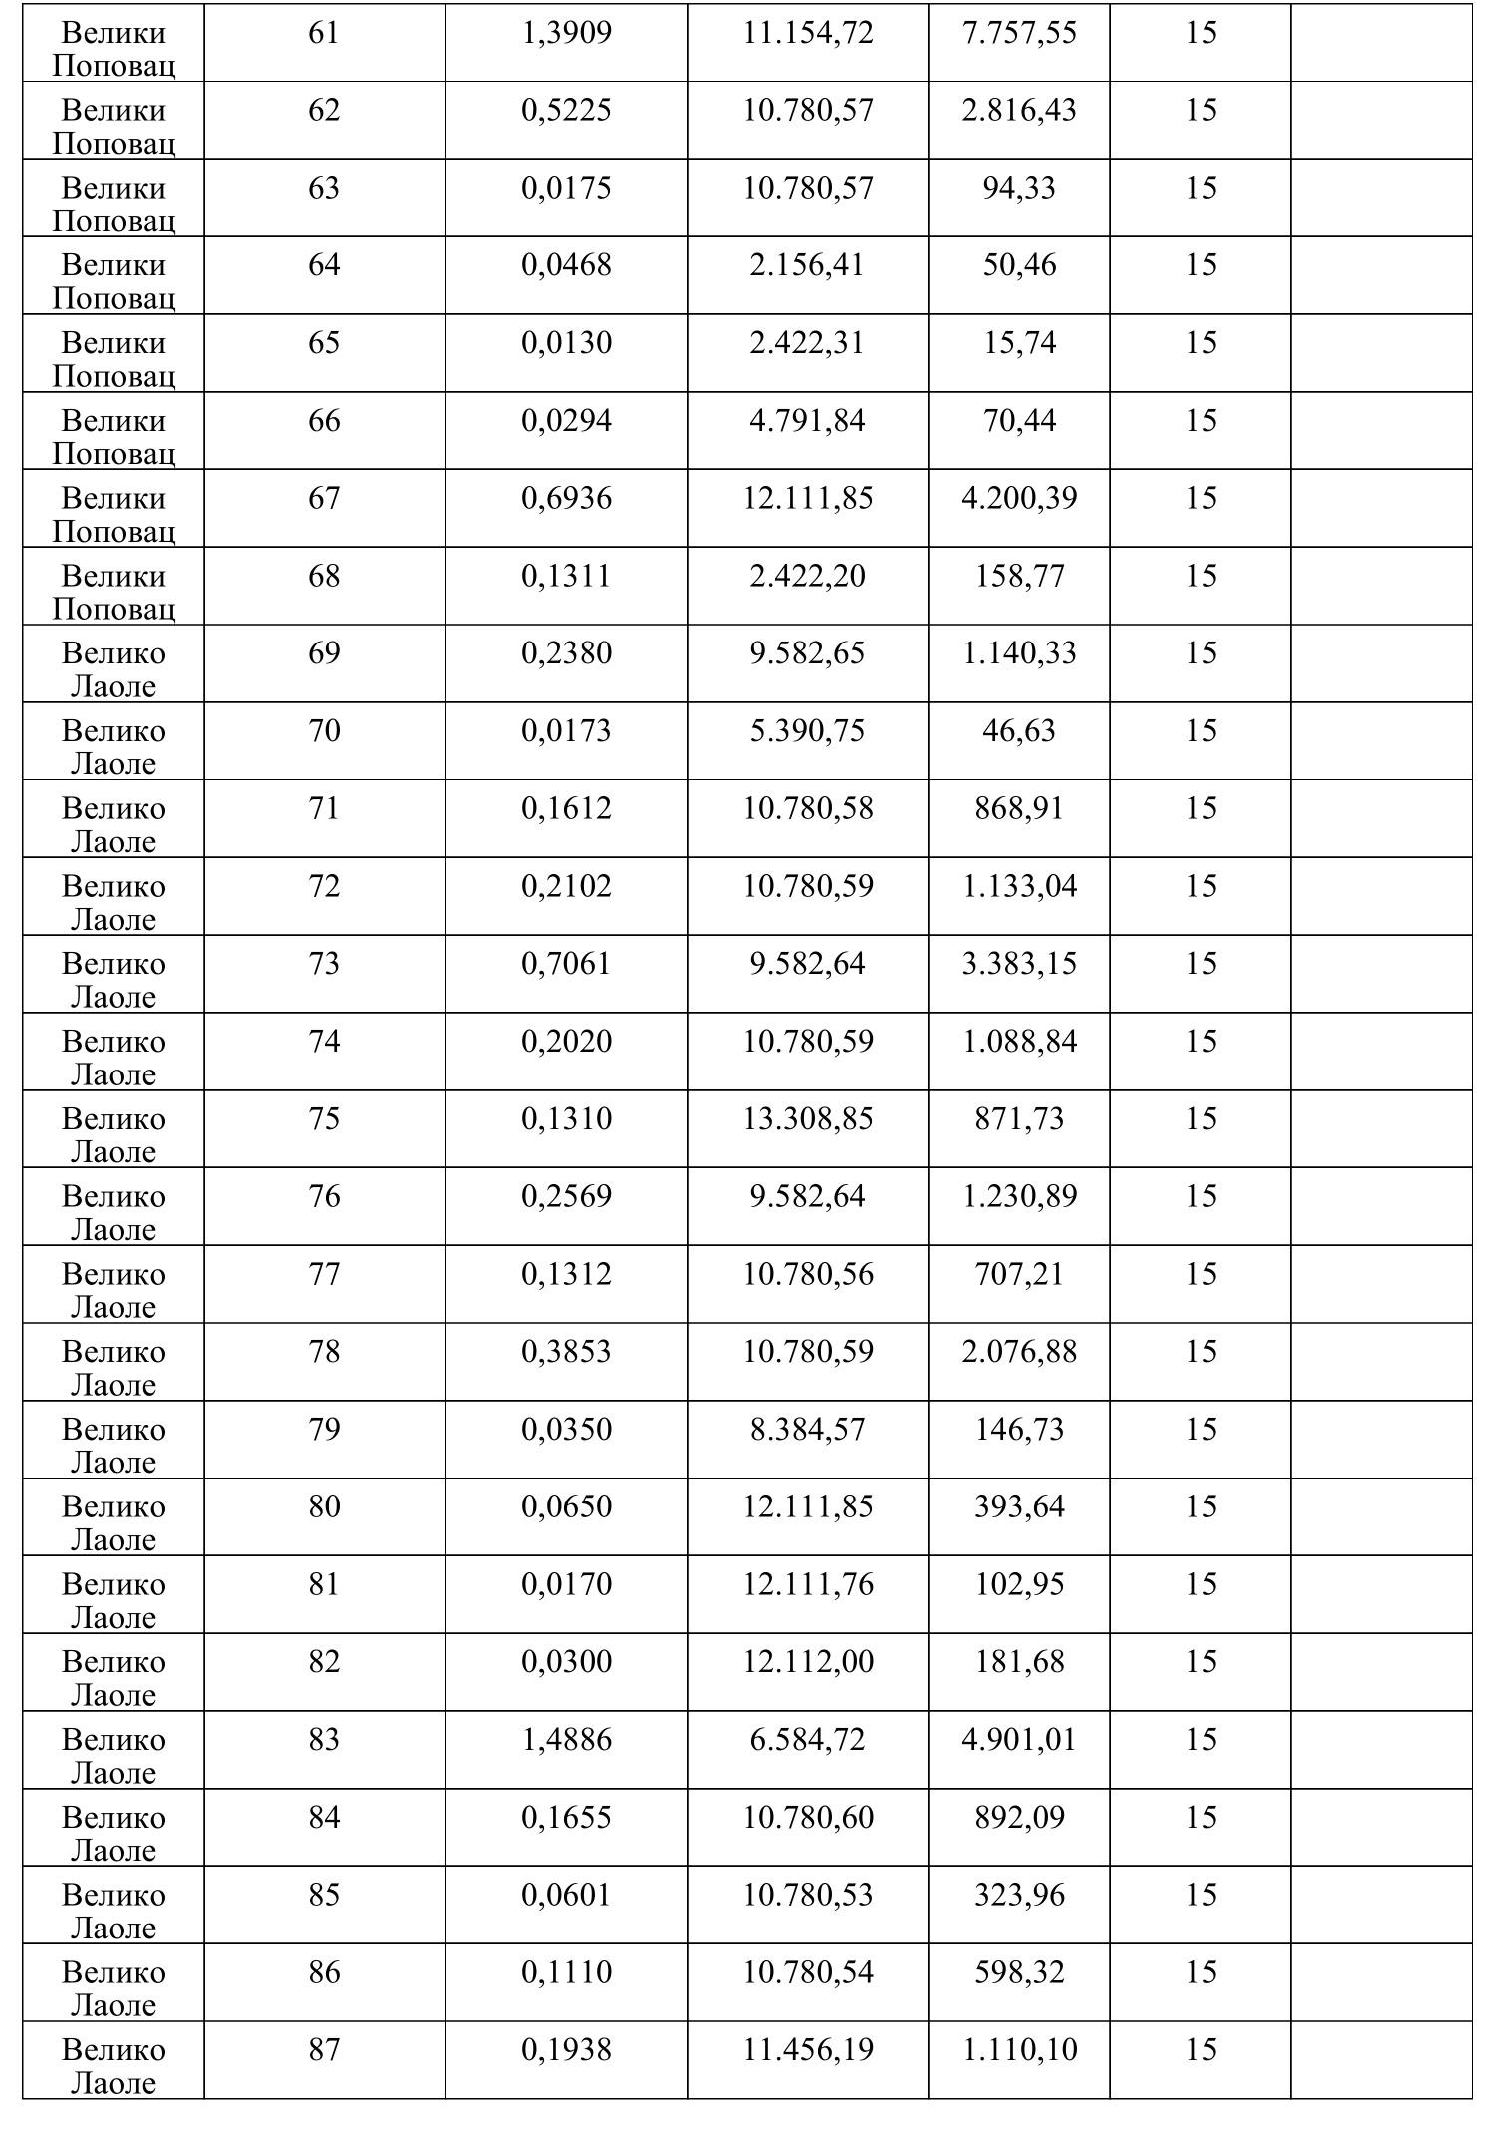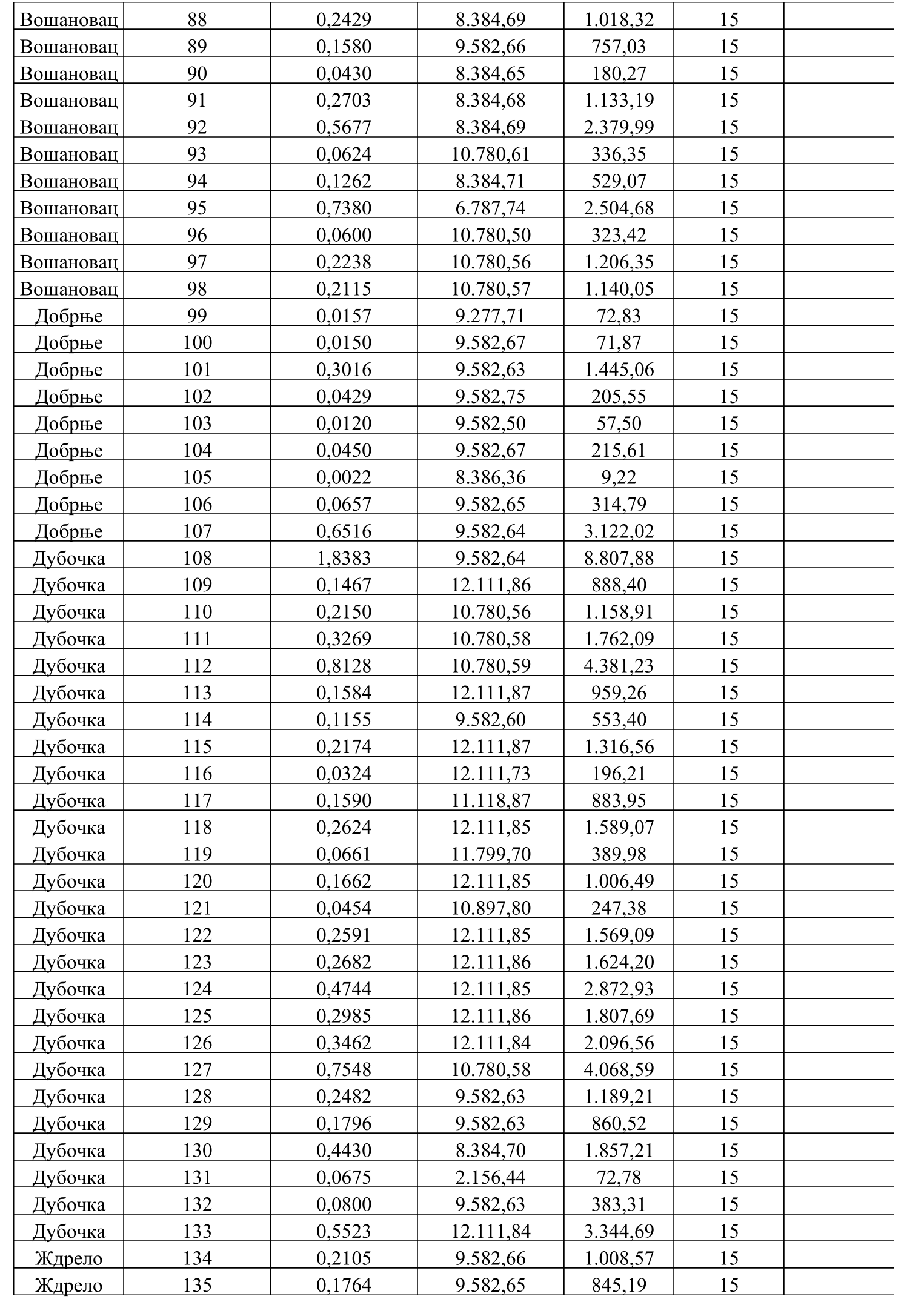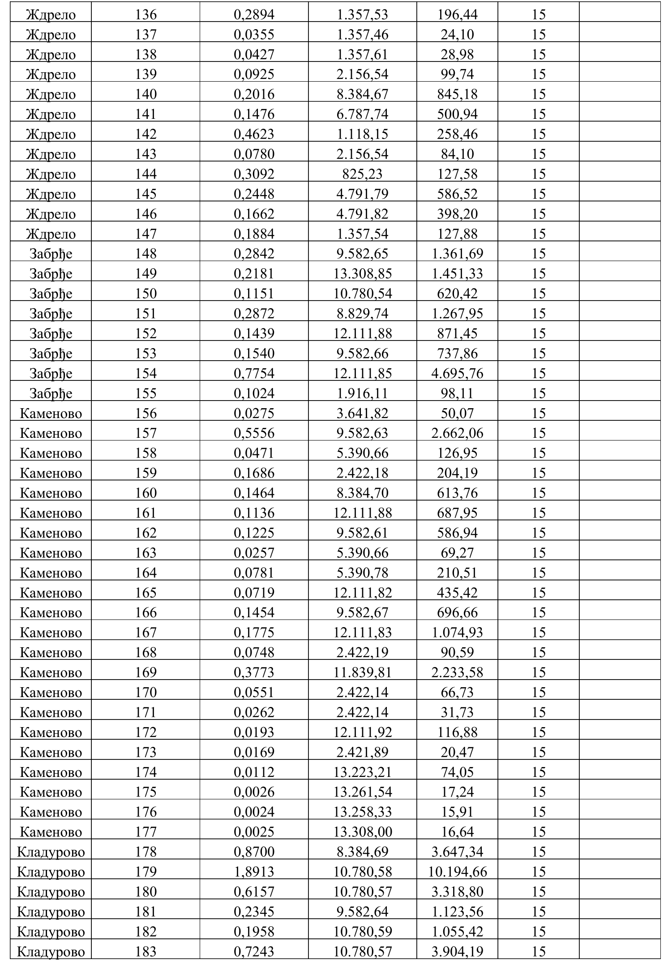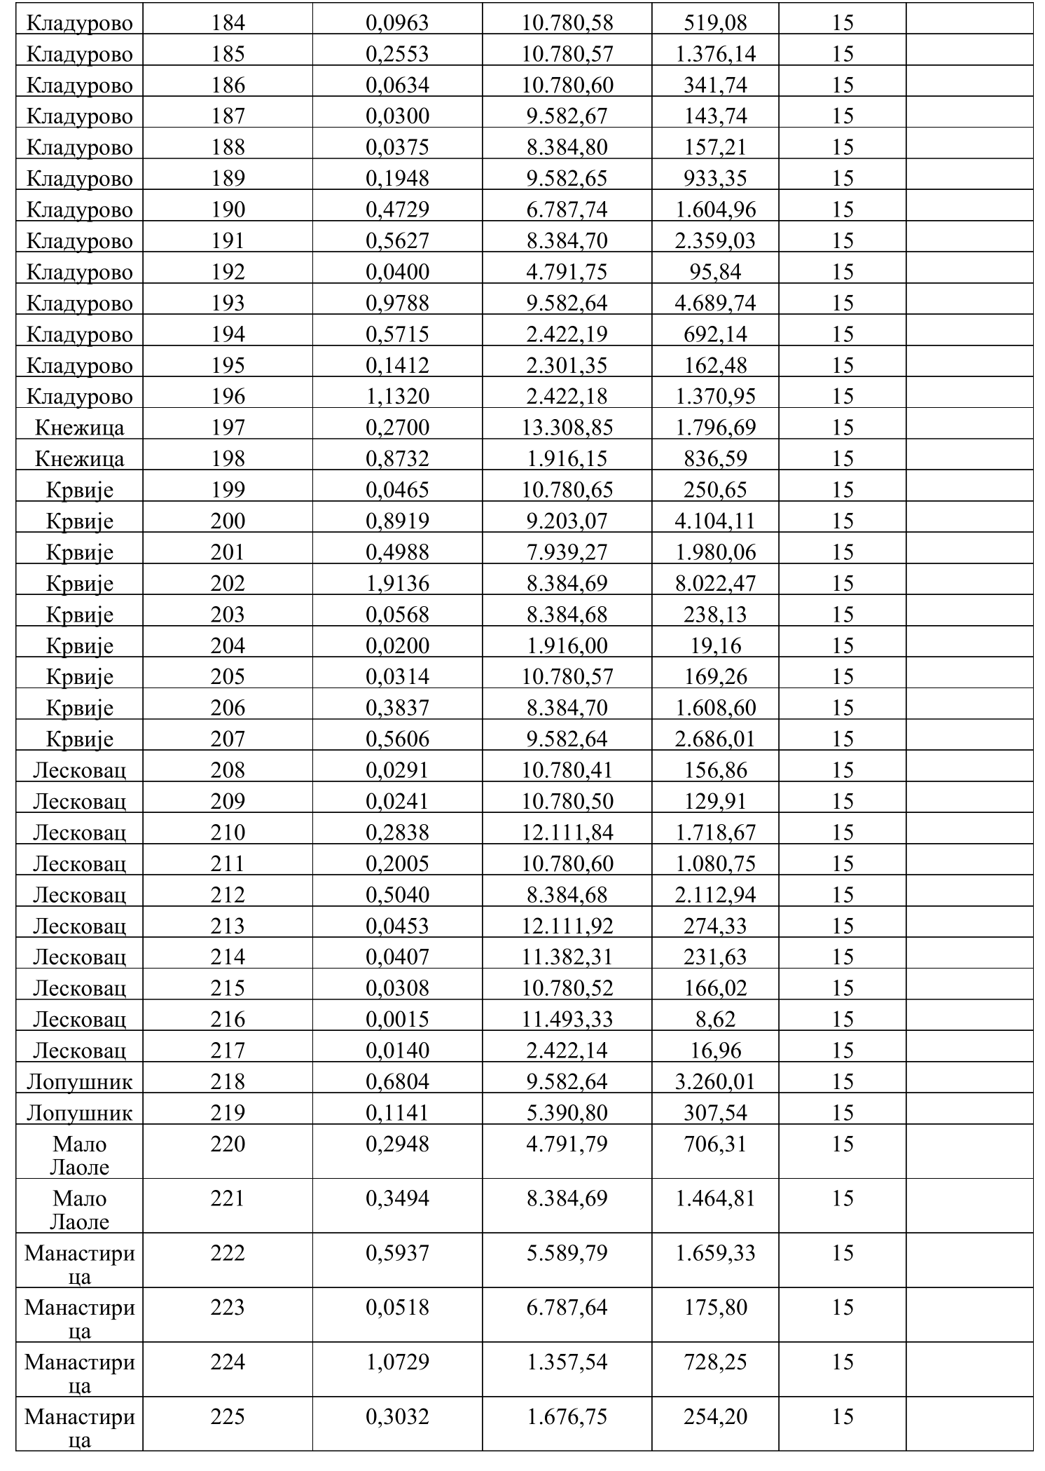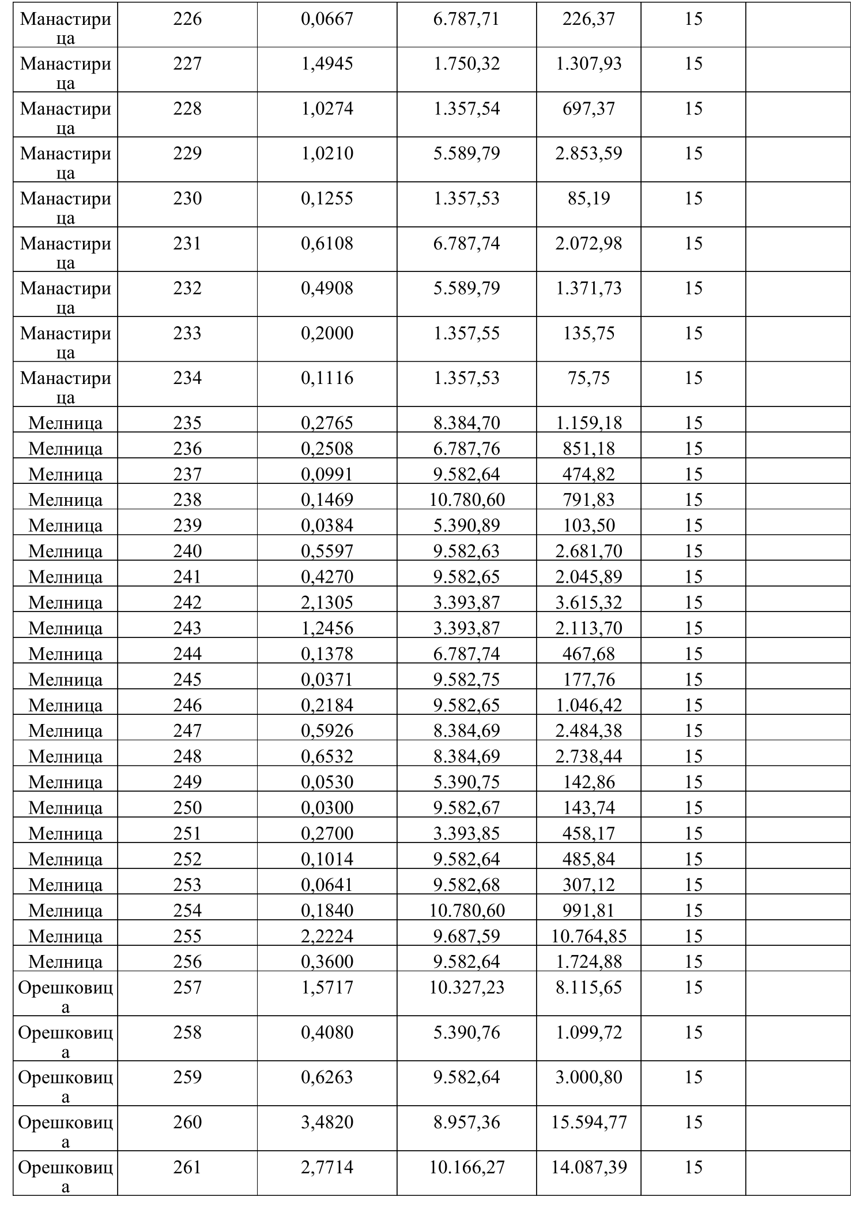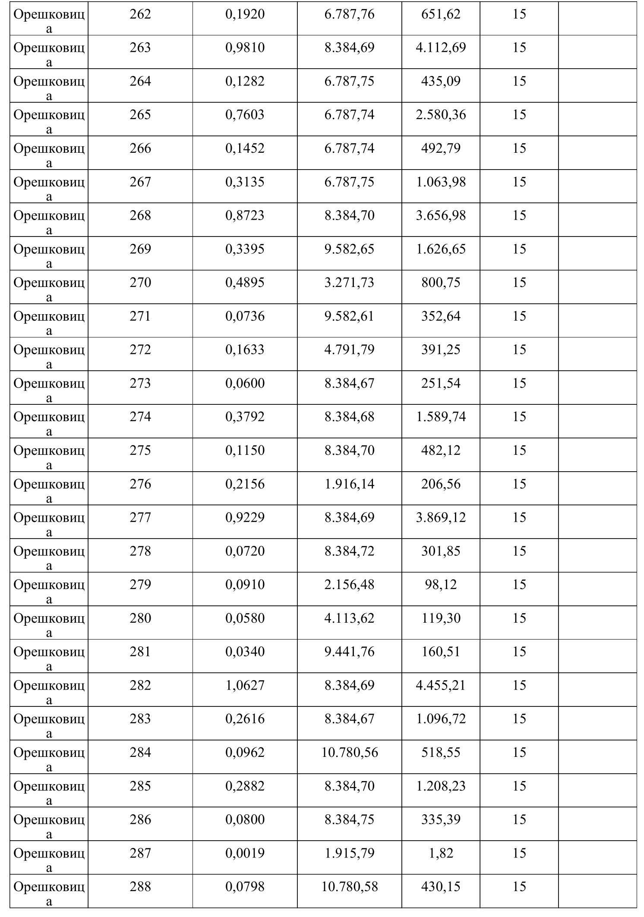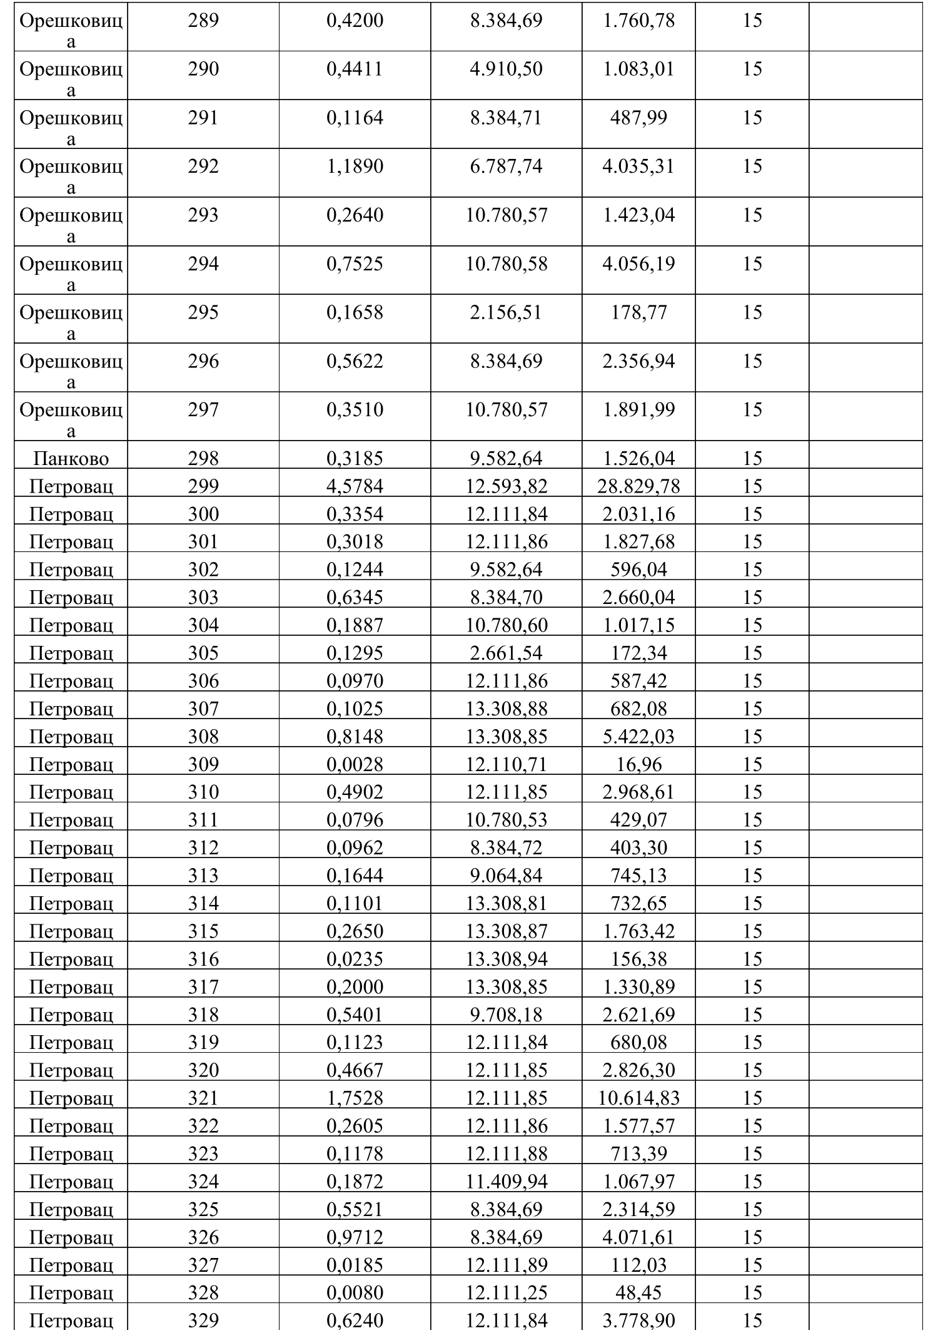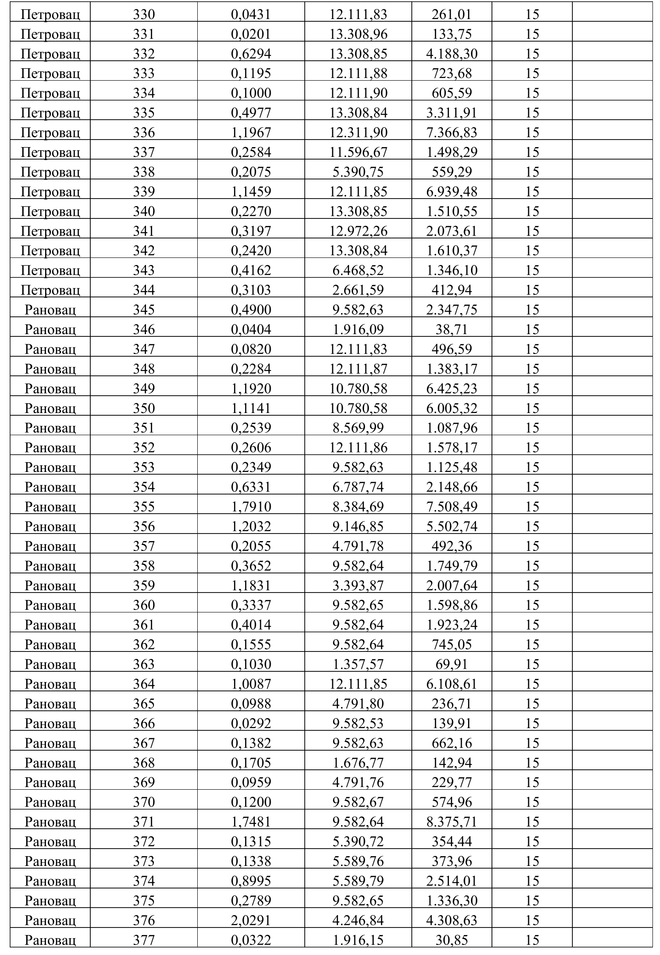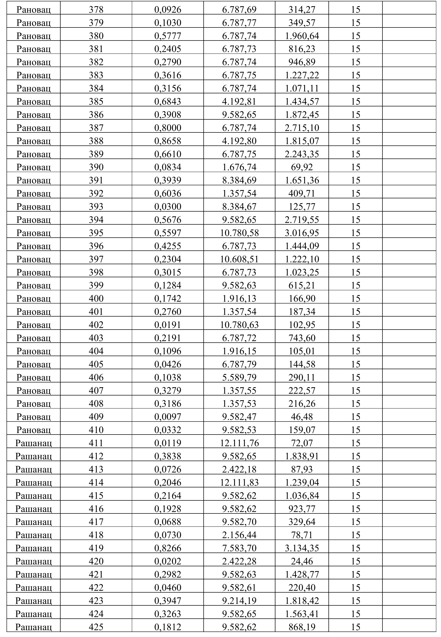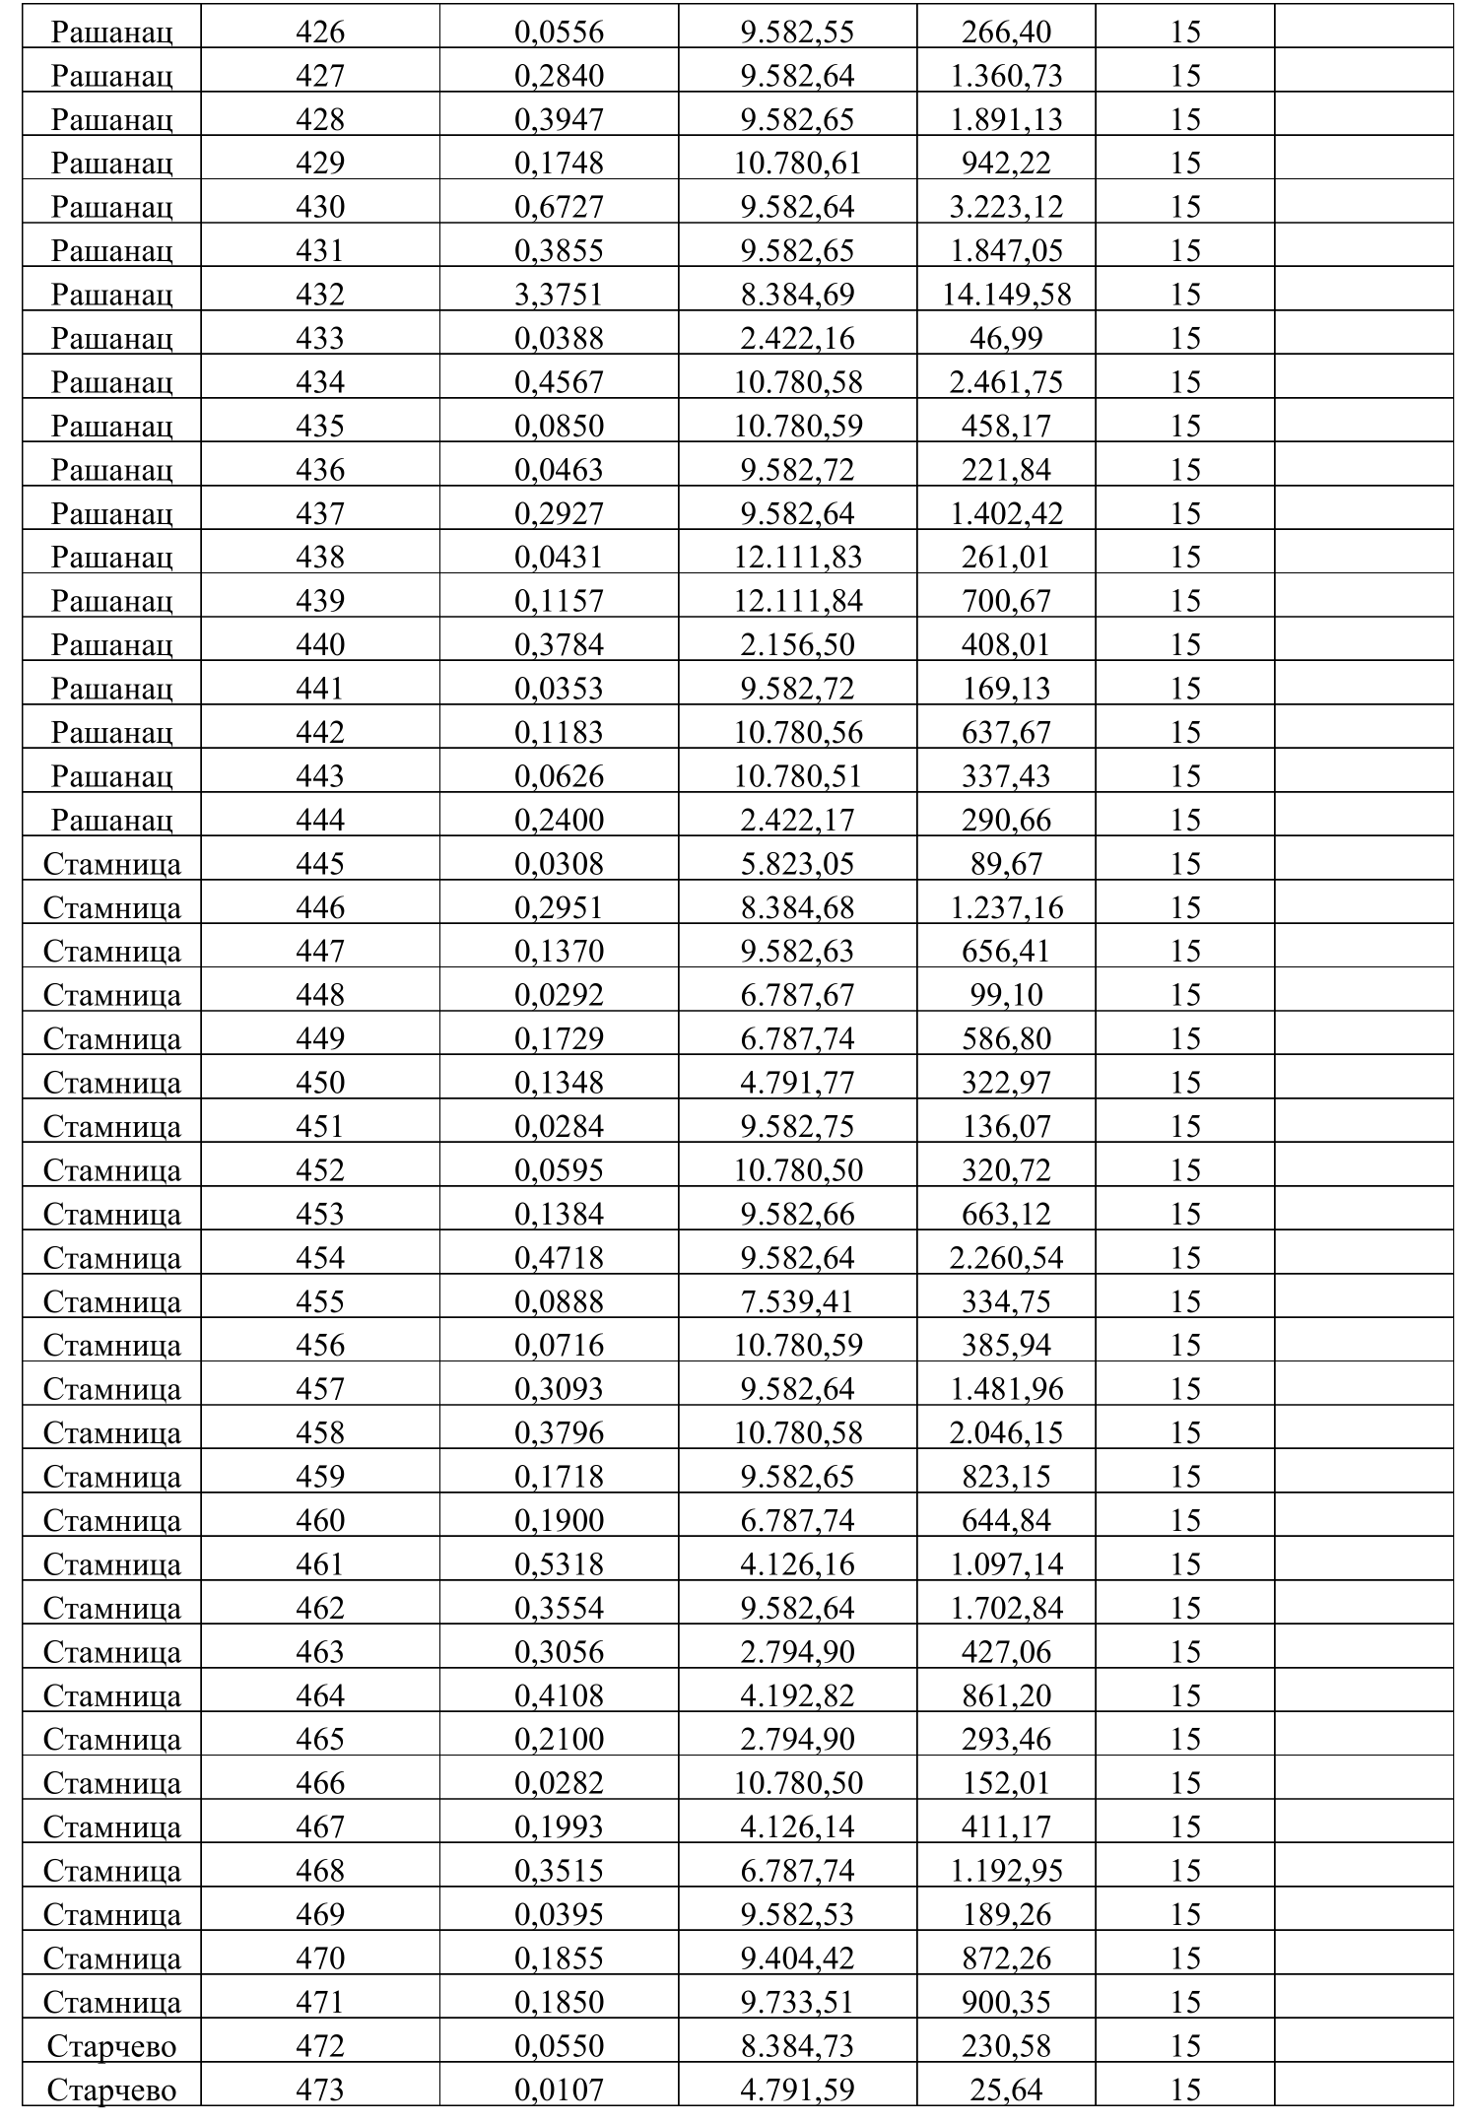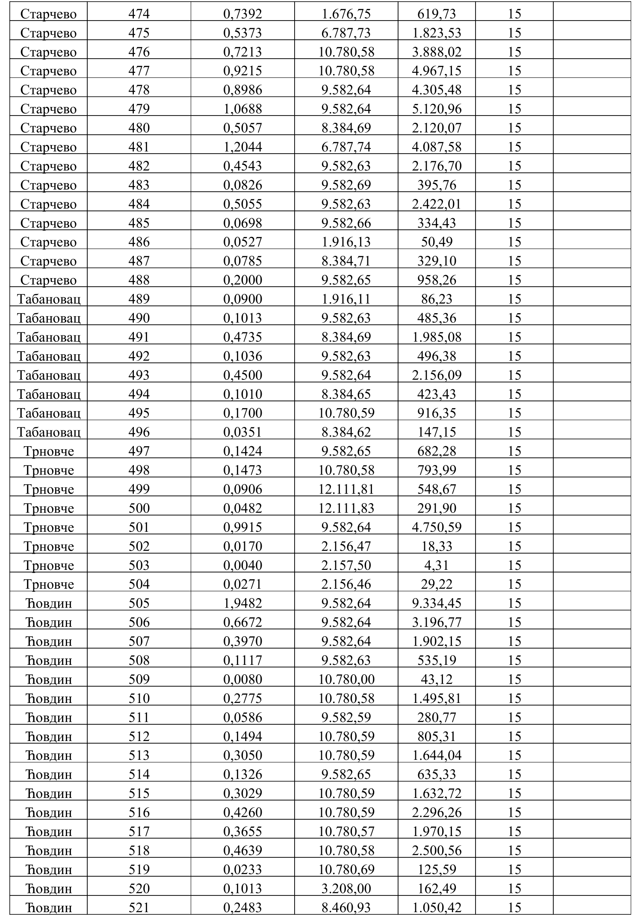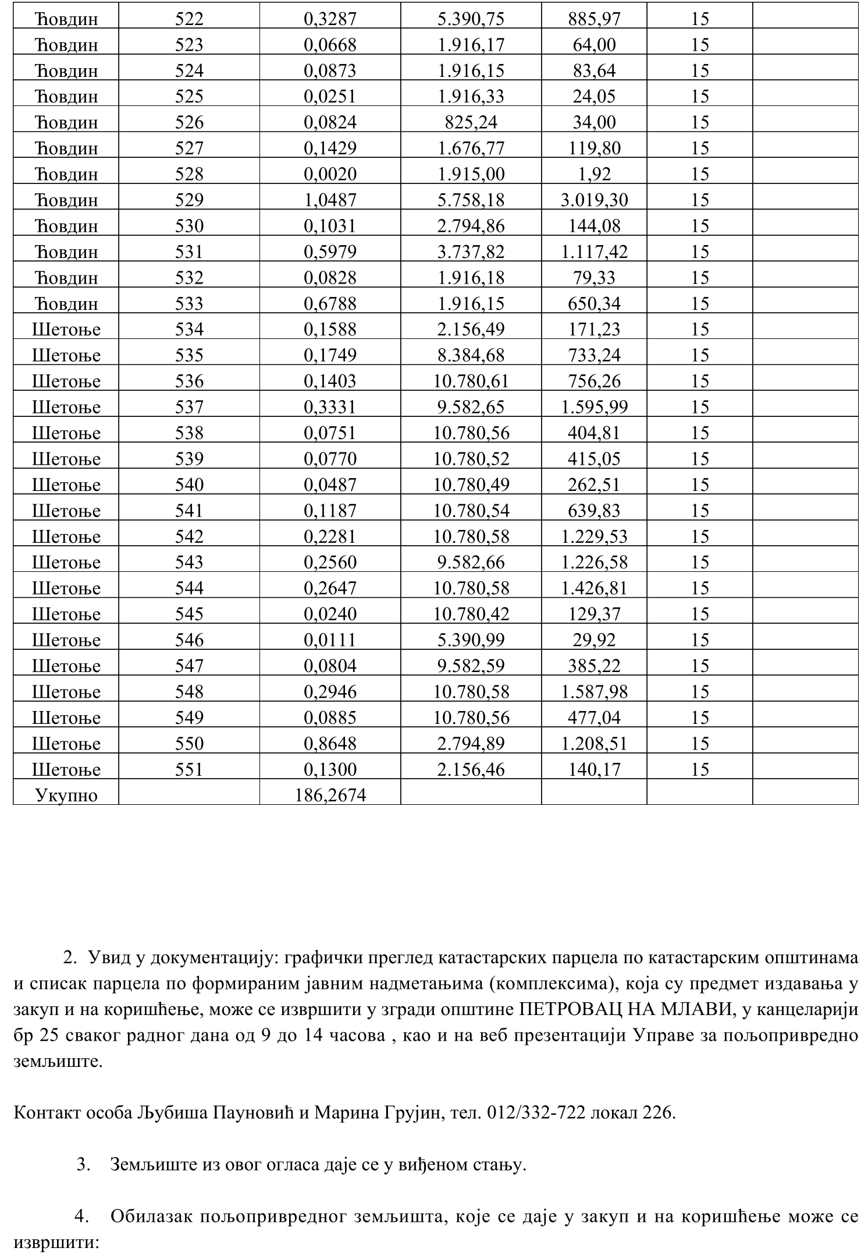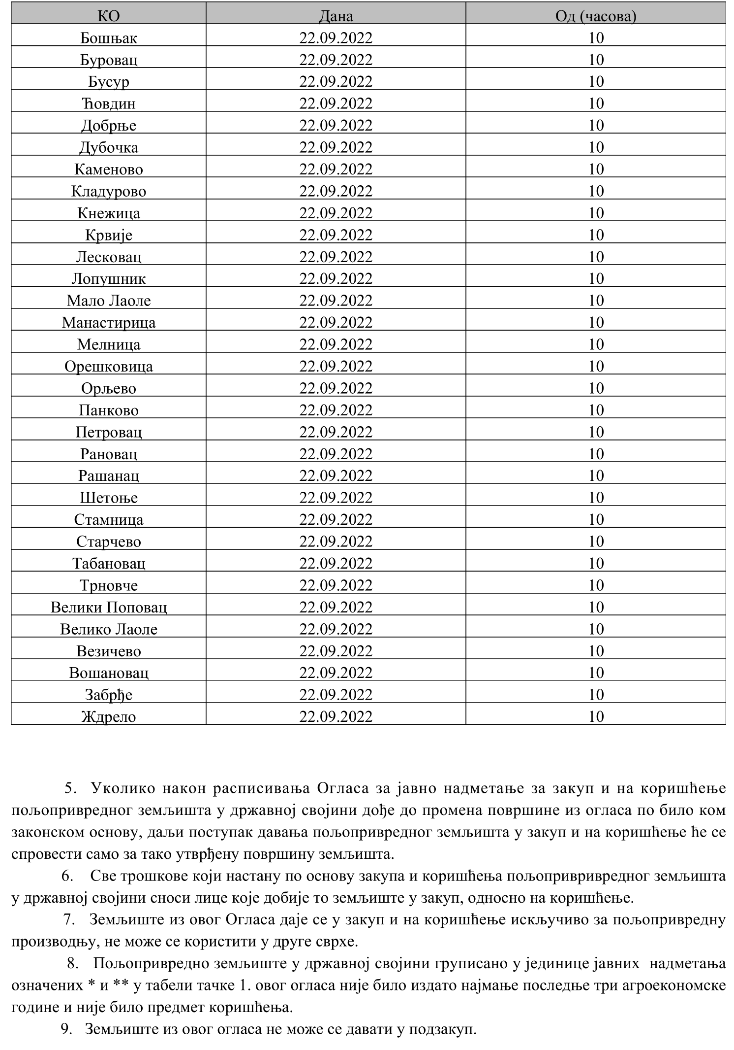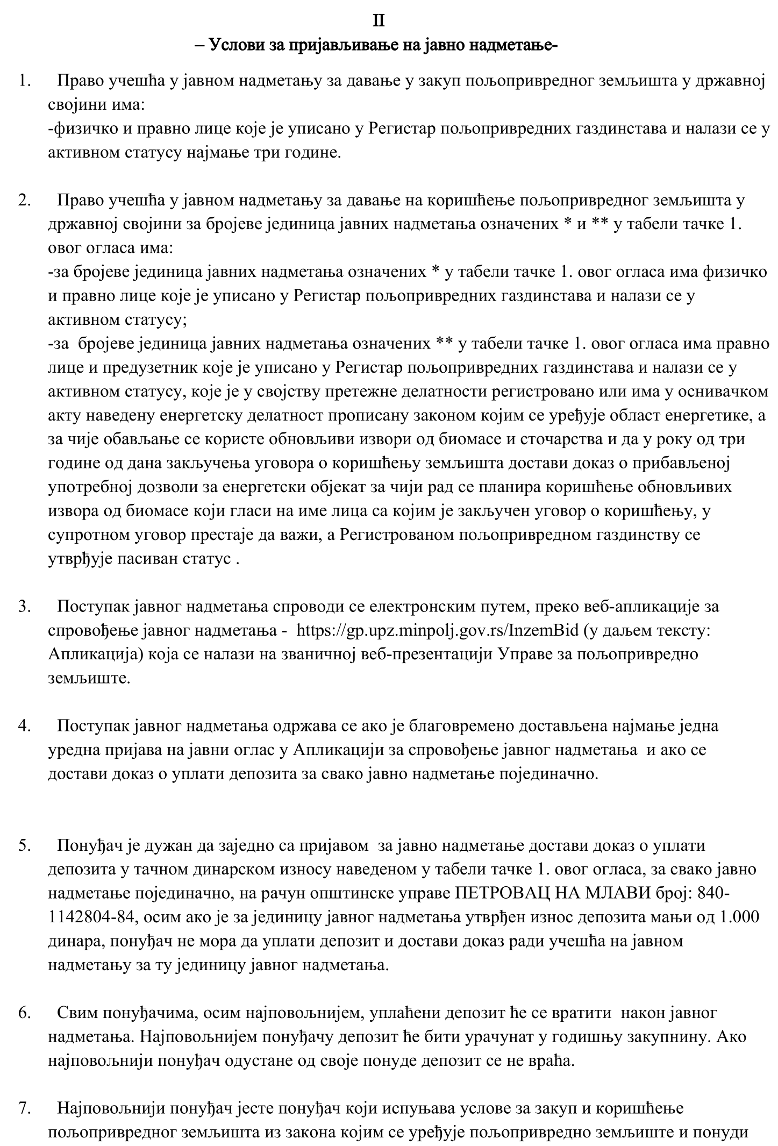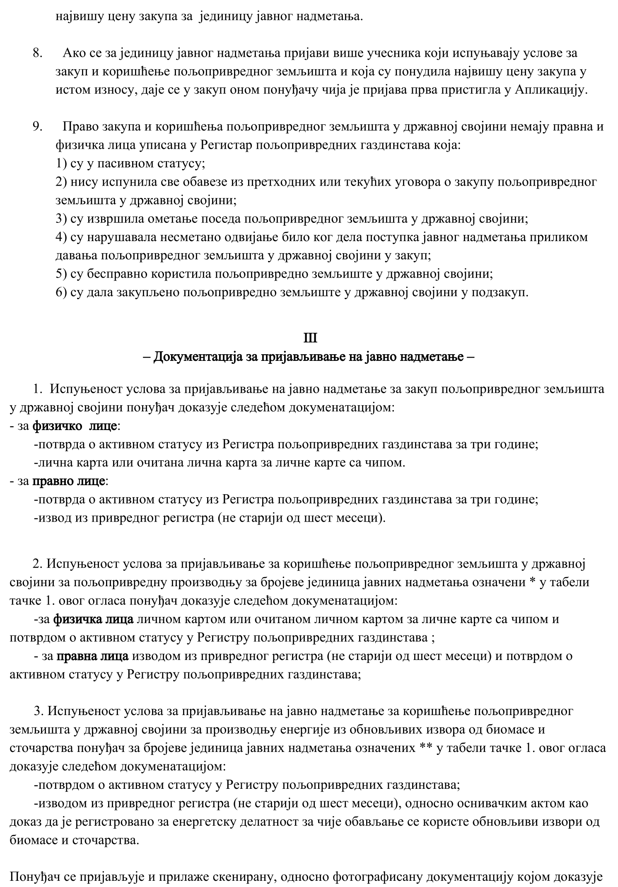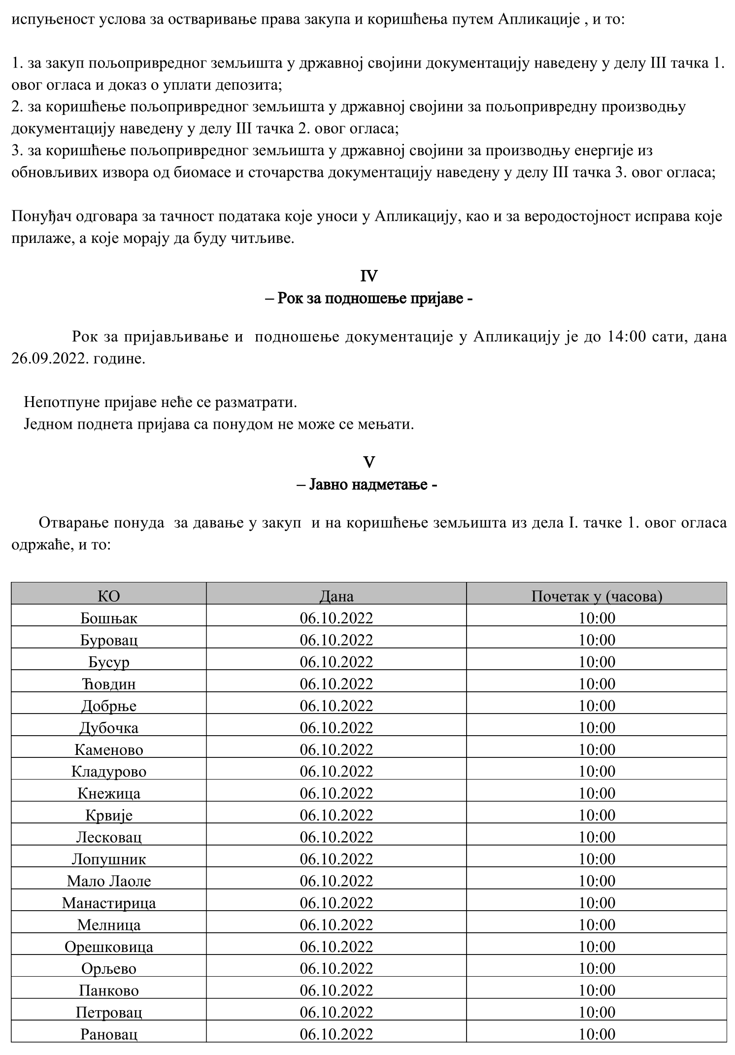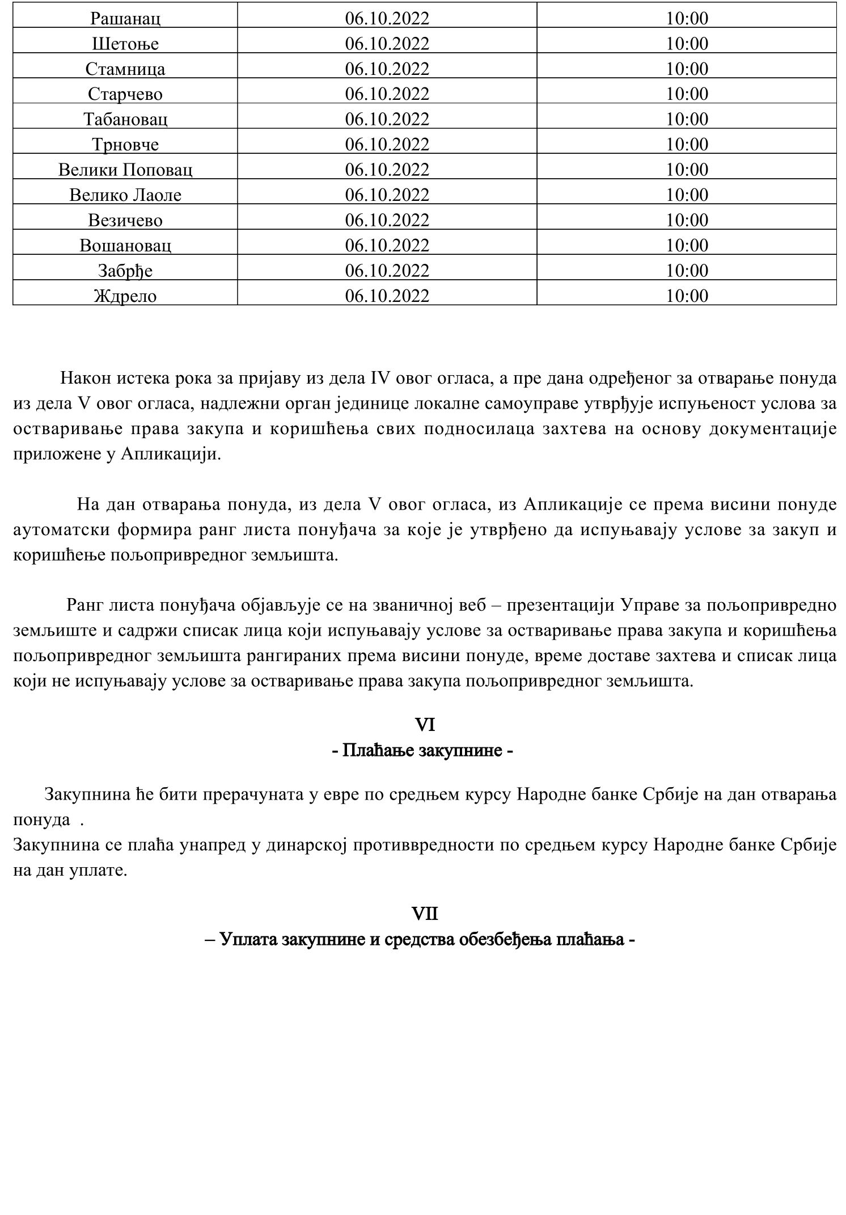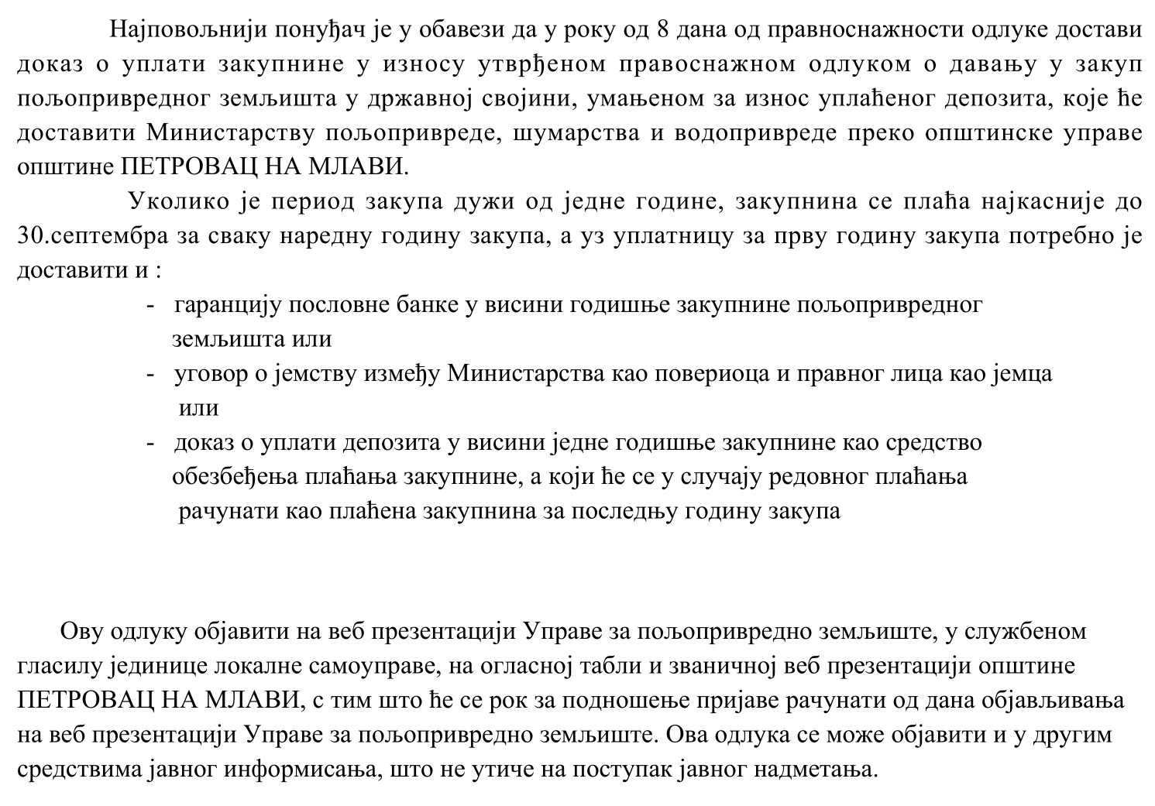

РЕПУБЛИКА СРБИЈА
ОПШТИНА ПЕТРОВАЦ НА МЛАВИ
Општинско веће
Број: 06-172/2022-01
Датум: 08.09.2022. године

Председник општинског већа
Душко Нединић, с.р.

Б е л е ш к е :

____________________________________________________________________________________________________________

____________________________________________________________________________________________________________

____________________________________________________________________________________________________________

____________________________________________________________________________________________________________

____________________________________________________________________________________________________________

____________________________________________________________________________________________________________

____________________________________________________________________________________________________________

____________________________________________________________________________________________________________

____________________________________________________________________________________________________________

____________________________________________________________________________________________________________

____________________________________________________________________________________________________________

____________________________________________________________________________________________________________

____________________________________________________________________________________________________________

____________________________________________________________________________________________________________

____________________________________________________________________________________________________________

____________________________________________________________________________________________________________

____________________________________________________________________________________________________________

____________________________________________________________________________________________________________

____________________________________________________________________________________________________________

____________________________________________________________________________________________________________

____________________________________________________________________________________________________________

Б е л е ш к е :

____________________________________________________________________________________________________________

____________________________________________________________________________________________________________

____________________________________________________________________________________________________________

____________________________________________________________________________________________________________

____________________________________________________________________________________________________________

____________________________________________________________________________________________________________

____________________________________________________________________________________________________________

____________________________________________________________________________________________________________

____________________________________________________________________________________________________________

____________________________________________________________________________________________________________

____________________________________________________________________________________________________________

____________________________________________________________________________________________________________

____________________________________________________________________________________________________________

____________________________________________________________________________________________________________

____________________________________________________________________________________________________________

____________________________________________________________________________________________________________

____________________________________________________________________________________________________________

____________________________________________________________________________________________________________

____________________________________________________________________________________________________________

____________________________________________________________________________________________________________

____________________________________________________________________________________________________________

Б е л е ш к е :

____________________________________________________________________________________________________________

____________________________________________________________________________________________________________

____________________________________________________________________________________________________________

____________________________________________________________________________________________________________

____________________________________________________________________________________________________________

____________________________________________________________________________________________________________

____________________________________________________________________________________________________________

____________________________________________________________________________________________________________

____________________________________________________________________________________________________________

____________________________________________________________________________________________________________

____________________________________________________________________________________________________________

____________________________________________________________________________________________________________

____________________________________________________________________________________________________________

____________________________________________________________________________________________________________

____________________________________________________________________________________________________________

____________________________________________________________________________________________________________

____________________________________________________________________________________________________________

____________________________________________________________________________________________________________

____________________________________________________________________________________________________________

____________________________________________________________________________________________________________

____________________________________________________________________________________________________________

_________________________________________________________________________________

ОСНИВАЧ:
СКУПШТИНА ОПШТИНЕ ПЕТРОВАЦ НА МЛАВИ, Одлука бр. 020-93/2006-02 од 05.06.2006. године и Одлука бр. 020-100/2008-02 од 18.07.2008. године

ИЗДАВАЧ:

ОПШТИНСКА УПРАВА ОПШТИНЕ ПЕТРОВАЦ НА МЛАВИ

Главни и одговорни уредник:
дипл. правник Милица Марковић, секретар Скупштине општине Петровац на Млави
телефон: 012 / 331 - 280 , факс: 012 / 331 - 283

Стручна обрада материјала:

Служба за скупштинске послове
_________________________________________________________________________________
Штампа: "Хипотрејд" Петровац, 012 / 327 - 645

